How to attend the virtual conference
如何参加RPG 2021 线上会议
Dear All RPG 2021 Delegates,
尊敬的RPG 2021 参会作者,
As the conference is getting closer, I am writing to send you some detailed information with regard to the virtual conference. All authors who have report to do (both poster and oral) should firstly follow the procedure below to complete your presentation. Then you should login to the registration system during the two days, read and comment on the posters/oral presentations.
会议临近，特此向您分享一些关于线上会议的具体操作流程及说明。所有文章作者(海报展示或口头报告)需要按照以下汇报流程完成您在此次会议上的文章展示，其余时间可通过注册系统查看其他会议海报/口头报告/主旨报告等。

Reporting Procedure (All Authors) 作者文章汇报流程 (所有作者)
- Oral Presentation口头报告
- Login the Registration system, join the Tencent Live conference and your paper reporting room on time
登陆注册系统，按照您口头报告的时间和相应的主题, 在会议开始前进入会议室准备
- Rename yourself with your paper ID
将会议室中您的昵称改为文章编号
- The session chair will introduce you and then you shall share your screen and make your speech within 15 min (including Q & A).
在session chair 简单介绍后，共享您的PPT并进行15分钟线上口头汇报（包含答疑时间）。
- You need to be there and answer other delegates’ questions at your speech slot
您需要在线参会并对作者提出的疑问进行答疑

- Poster Presentation Reporting Procedure 海报展示
- Login to the registration system
登陆注册系统
- Check whether there is any questions for your poster during the two days
在会议两天内及时查看是否有参会人员向您的海报进行提问
- Answer questions in time
及时回答来自其他参会人员的提问

Participating Procedure (All delegates including authors)
参会流程 (所有人员包括作者)
Step 1: Download Tencent Meeting 下载腾讯会议
RPG 2021 uses Tencent Meeting to broadcast all the keynote speeches and session reports online. All participates should download the APP pre-conference or use Wechat mini program to login to Tencent Meeting via mobile phone.
RPG 2021 会议采用腾讯会议直播所有主旨演讲报告及分论坛报告。所有参会人员应提前下载腾讯会议软件或通过手机微信小程序登录腾讯会议。
- Download Chinese Version中文版本下载 （1.5.0及以上版本）
https://meeting.tencent.com/
- Download English Version (version of or beyond 1.5.0)
https://voovmeeting.com/
Step 2：Login 登录注册系统
All registered delegate should login to the registration system using the link below
所有注册用户需要使用以下链接登录注册系统
http://events.theiet.org.cn/meeting/reg_en_login.asp?id=2349
Step 3: Live Conference 会议直播间
Go to Online Conference --- Live conference, to attend the meeting.
点击“线上会议---会议直播”参加RPG 2021 线上会议
* Online Conference will be opened on the day of the conference and is currently unavailable 会议当天会开放在线会议栏目，目前尚未开放观看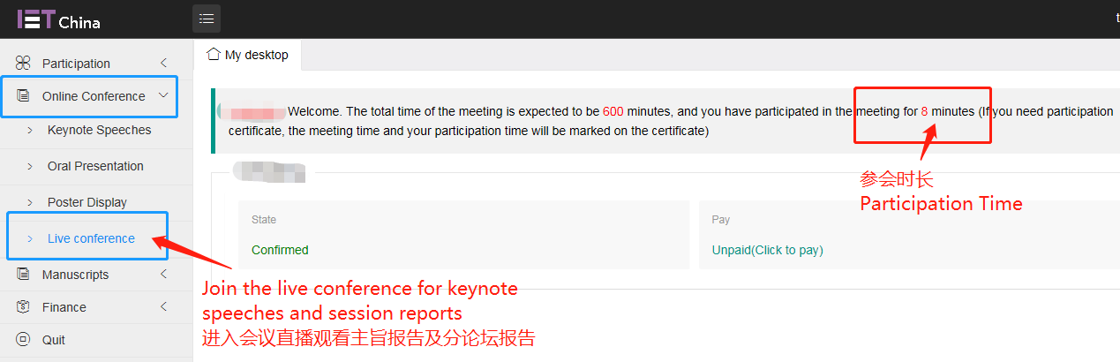
If you have any questions to the keynote speaker you can ask by leaving a comment in the chat box
在线提问可在演讲嘉宾演讲时通过留言区留言。
Step 4: View the oral presentation/posters 查看口头报告及海报
All keynote speeches and session report will not be displayed until the live conference ends
主旨报告及所有分论坛口头报告在会议直播期间不显示，请关注会议直播
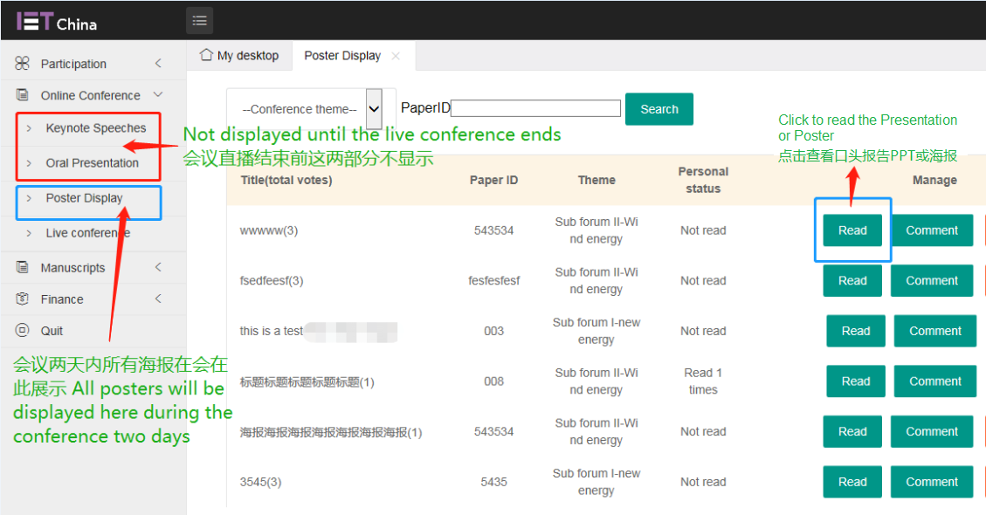

Step 5: Comment 留言
You can comment on the paper or leave a message / question for the author. All poster presenters should check if there is any question for your paper and answer them in time.
您可以对报告进行提问或留言。所有作者应该及时查看留言并做出回复。
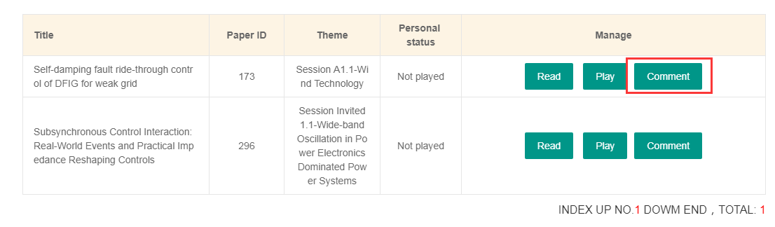

Step 7: Download conference proceeding 会议论文集下载
After the event we will email all the authors the link and password to download the conference proceeding
会后我们也会邮件所有作者告知下载链接和提取码
FAQ 常见问题
- How to require a participation certificate
如何获取参会证明
To require a participation certificate, please take a screenshot showing your participation time and email your registration ID and the screenshot to event@theiet.org.cn for the official participation certificate.
如需参会证明，请您截图显示您的参会时长并将截图及会议注册码（SN number）发送至event@theiet.org.cn 索取正式参会证明。

- Can I invite other co-authors to attend the virtual conference?
是否可以邀请他人加入线上会议室
Currently the maximum number of delegates in each conference room on Tencent Meeting is 300 therefore only registered users are allowed to participate in the Tencent meeting and communicate with the speaker.
目前腾讯会议一个会议室允许的参会人数上限为300人，为保证注册人员的参会权利，只有注册人员可以进入会议室并与嘉宾进行在线交流

- What are the differences between a registered delegate and a general public viewer?
注册参会人员与社会观众有哪些区别?
Registered delegates 注册人员
- can view/comment/discuss in the live conference room 可以加入线上会议室查看/留言/讨论
- can read/comment on all the posters 可以阅读所有海报及留言
- can download conference proceeding of RPG 2021 可以下载RPG 2021 会议论文集
- can replay all the oral presentations after the live conference 可以回看所有口头报告
General public viewer 社会观众
- Can view the keynote speeches via weibo/Bilibili while it is broadcasting only.
只能通过微信或B站在会议直播时段观看演讲

